A Proposal to Predict Dog Breed

Proposed by:

Rachel Tumulak

# Domain Background

Image classification is the process of identifying through computer vision the visual content of an image.

There are a lot of applications image classification can be used for such as face recognition, self-driving

cars, automatic vacuum cleaner and a lot more. Common to these applications include identifying an

object. An example is identifying whether a human face is in a picture or not to recognize face of a

human. For a self-driving car to be able to drive automatically, it needs to identify stoplights, signs, and

humans to drive safely. Vacuum cleaners need to identify if an object is a dirt and needs to be cleaned,

or a wall to change its direction.

There are a wide range of species in the world, human with a curious mind sometimes just wants to

know what specie that is. In each specie there are a lot more classifications. An example would be

animals. There are a lot of animals in the world that some even look similar. Tigers, lions, leopards have

common features and they belong in the Cat family. There are also domestic cats which are separated in

terms of its breed. For a human to detect what breed a cat would be is challenging due to many factors.

A dog breed can be identified through behavior, body type, face, and ear shape, vocal, color, fur,

markings and patterns, body size and mannerism. In an image one can only focus on what can be seen

namely body type, face and ear shape, color, fur, markings and patterns, and body size.

Machine learning, as a subset of artificial intelligence, provides system the ability to learn and improve

automatically through experience. Image classification is one the topics in machine learning and a

common deep learning algorithm that is being used to analyze visual imagery is Convolutional Neural

Network or CNN.

# Problem Statement

This project aims to build a machine learning pipeline that will identify an estimate of a canine’s breed. The most identifiable characteristic in a canine is its coat color, pattern, and length. Consider that even a human would have trouble distinguishing between a Brittany and a Welsh Springer Spaniel

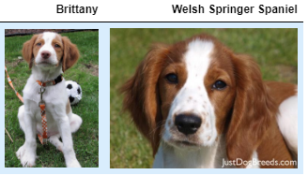

It is not difficult to find other dog breed pairs with minimal inter-class variation (for instance, Curly-Coated Retrievers and American Water Spaniels).

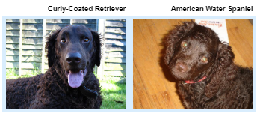

Likewise, recall that Labradors come in yellow, chocolate, and black. Your vision-based algorithm will have to conquer this high intra-class variation to determine how to classify all of these different shades as the same breed.

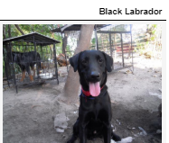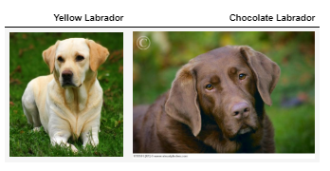

# Datasets and Inputs

* unbalanced dataset of images representing 133 different dog breeds

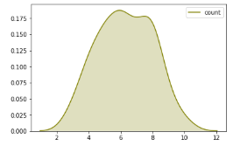

*Figure A. Distribution of cat breeds*

* there are 8351 total dog images
  + 1/10 of the total images are to be used for testing
  + 1/10 of the total images are to be used for validation
  + 8/10 of the total images are to be used for training
* There are 13233 total human images
* For training the images will be transformed:
  + Random rotation
  + Random resize
* All datasets are resized to fit the model
* The dataset was made available by Udacity Machine Learning Engineer Nanodegree Program

# Solution Statement

A proposed solution to this problem is to undergo two approaches of Convolutional Neural Network.

1. **Traditional**. I will then construct a Convolutional Neural Network from scratch that will identify cat breeds.
2. **Transfer Learning.** I will use an existing CNN model that has been trained and use its knowledge for training the newer model.

First, I will use VGG16 pretrained model to detect if a dog exists in a picture. All images will be transformed into randomly rotated and resized for training. Second, I will build a convolutional neural network from scratch to predict the breed of the dog. Third, to improve the model, I will use an existing CNN model that has been trained, ResNet18, and use its knowledge for training the newer model.

According to the observations of researchers, in convolutional neural network, the deeper the better. However, even if the models tend to become more capable after some depth the performance degrades. When the network goes too deep, calculating the gradients from a loss function shrinks to zero after several application of the chain rule. Which results to no learning performed. ResNets solves this problem by allowing the gradients to directly flow through the skip connections backwards from the later layers to initial filters.

# Benchmark Model

For this project, CNN from scratch will serve as a baseline for the performance of my actual model.

## Convolutional Neural Network

Computer vision is to allow computers to perceive images just as humans can see. There are many advancements towards this agenda, and it is primary based on Convolutional Neural Network. ConvNet or CNN takes images, distinguish learnable weights and biases to various objects that will enable it to differentiate one object to another. Its architect is based that of a neuron in the human brain where each neuron is respond to stimuli in a restricted region of the visual field – Receptive Field. A collection overlap to cover the entire visual area. Therefore, convnet can successfully capture Spatial and Temporal dependencies in an image through an application of relevant filters. By reducing the number of parameters involved and reusability of weights the network performs better since it can be trained to understand sophisticated images.

# Evaluation Metrics

To evaluate the model, I will use F1 score to determine model performance. F1 score is the weighted average of the precision and recall. Where an F1 score reaches its best value at 1 and worst score at 0. The relative contribution of precision and recall to the F1 score are equal.

$$f1 score=2 ×\frac{precision ×recall}{precision+recall}$$

# Project Design

The project will undergo the following procedures for its pipeline

1. Import Datasets
   1. Import the datasets that will be used for the project
2. Detect Humans
   1. Use OpenCV implementation of Haar feature-based cascade classifiers to detect human faces in an image
3. Use a pretrained model VGG16
   1. Use a pre-trained model that will detect if a cat exists in a picture
4. Create a CNN to Classify Dog Breeds (Scratch)
   1. Build a model from scratch to classify cat breeds
5. Create a CNN to Classify Dog Breeds (Transfer Learning)
   1. Improve the model by using transfer learning
6. Algorithm
   1. if a dog is detected in the image, return the predicted breed
   2. if a human is detected in the image, return the resembling dog breed
   3. if neither is detected in the image, provide output that indicates an error.

# Resources

<https://towardsdatascience.com/a-comprehensive-hands-on-guide-to-transfer-learning-with-real-world-applications-in-deep-learning-212bf3b2f27a>

<https://towardsdatascience.com/dog-breed-prediction-using-cnns-and-transfer-learning-22d8ed0b16c5>

<https://siameseofday.com/siamese-cat-colors-chart/>